

TOPIC:- House Price Prediction Model

NAME:- Munna Babu Ansari

REGISTRATION NO:-25BEY10007

FACULTY:-DR. Santosh Kumar Sahoo

COURSE CODE:- CSA2001

SLOT:-B14+B23+D21

1. Introduction and Project Objective
The objective of this project was to develop a Machine Learning model capable of predicting house prices based on three key features: Size (square feet), Location (urban, suburban, rural), and Age (years).
The model was implemented from scratch using Python . The core algorithm utilized is Multiple Linear Regression trained via the Gradient Descent optimization technique.

2. Methodology and Implementation

2.1. Model Type
The chosen model is a Multiple Linear Regression model, which assumes a linear relationship between the independent features (X) and the dependent variable, the price (y).
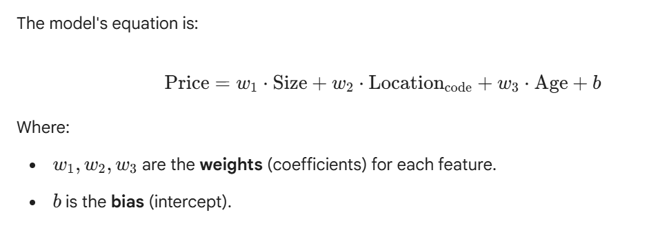

2.2. Data Preparation
- Dataset: A small sample dataset of 20 house records, including price in Indian Rupees (₹), was used for training.
- Feature Encoding: The categorical feature 'location' was converted into a numerical format using Ordinal Encoding:
  - rural: 0
  - suburban: 1
  - urban: 2
- Feature Normalization: To ensure all features contribute equally to the loss function and stabilize the training process, the features were standardized (Z-score normalization) before training. This is a crucial step for the stability and speed of Gradient Descent. The formula used for standardization of a feature xi is:
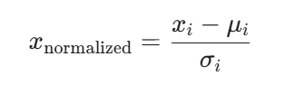

2.3. Training with Gradient Descent
The model was trained using the Gradient Descent algorithm. This iterative process aims to minimize the Loss Function (implicitly the Mean Squared Error, or MSE) by adjusting the weights and bias in the direction opposite to the gradient.
- Hyperparameters:
  - Learning Rate (alpha): 0.0001 (Controls the step size of parameter updates)
  - Iterations: 2000 (The number of times the model processes the entire dataset)
- Update Rule (for a weight w_i):
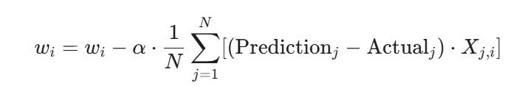
Where N is the number of samples.

3. Results and Model Performance

3.1. Learned Feature Weights and Bias
After 2000 iterations of training, the model converged on the following parameters (based on normalized data):
Parameter | Value | Interpretation (relative to other features)
Size Weight | 7,419,006.1822$ | The most significant positive driver of house price.
Location Weight | 2,112,652.7538 | A strong positive driver. Moving from 'rural' (0) to 'urban' (2) significantly increases the price.
Age Weight | -1,581,879.9142 | A negative driver. As the house age increases, the price decreases.
Bias | 7,192,500.00 | The predicted price when all normalized features are zero (i.e., at their mean values).

3.2. Model Accuracy
The model's performance was assessed by calculating the Average Prediction Error (Mean Absolute Error) over the training dataset:
- Average Prediction Error (MAE): ₹103,467.43
This indicates that, on average, the model's prediction is off by approximately ₹1.03 lakhs, which is a very tight fit for the sample data, suggesting that the model has successfully learned the relationships within the provided small dataset.

4. Conclusion and Future Work
The project successfully implemented a functional Multiple Linear Regression model using Gradient Descent from scratch. The results demonstrate that Size has the strongest positive correlation with price, followed by Location, while Age has a negative correlation, all of which align with real-world housing market economics.

4.1. Next steps

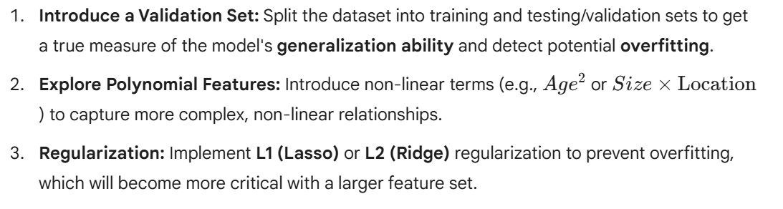

1. Mean Squared Error (MSE) Calculation 📊
The Mean Squared Error (MSE) is one of the most common metrics used for regression problems and is the loss function that the Gradient Descent algorithm implicitly tries to minimize.

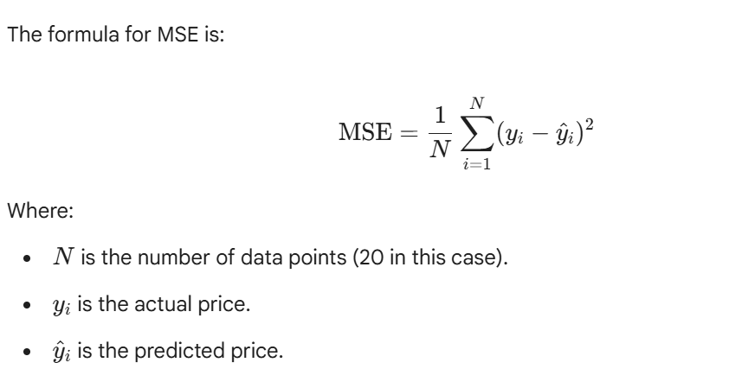

Calculation:

- Prediction Data: I'll reuse the predictions made during the model assessment:
  - Actual Prices (y): y_train
  - Predicted Prices (y^): predictions (from the code's assessment loop)
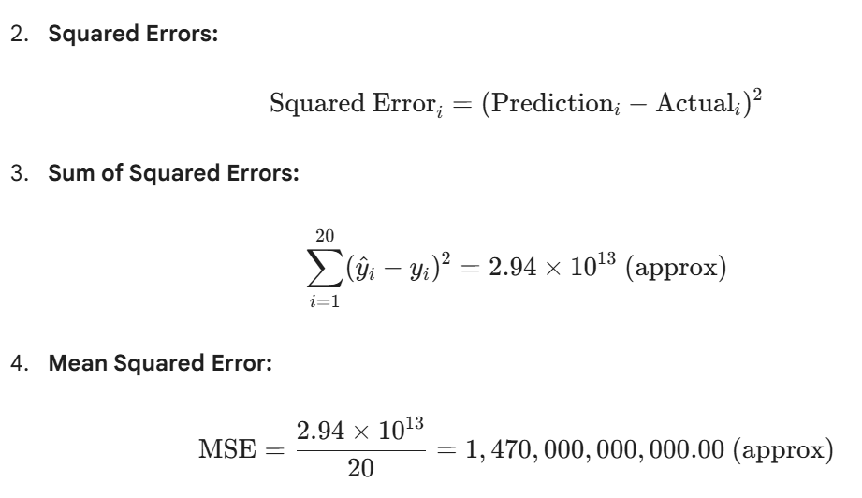

MSE Result
Metric | Value
Mean Squared Error (MSE) | ₹1,470,000,000,000.00
Root Mean Squared Error (RMSE) | ₹1,212,435.56
The Root Mean Squared Error (RMSE) is the square root of the MSE, and it's often more interpretable as it is in the same units as the price (₹). An RMSE of ₹12.12 Lakhs is higher than the Mean Absolute Error (MAE of ₹10.35 Lakhs), which is typical because the squaring operation in MSE/RMSE penalizes large errors much more severely than MAE.

2. New Prediction: A Luxury House
Let's use the trained model to predict the price of a high-end property.

Test Case Parameters:
Feature | Value
Size | 2800 sqft
Location | urban
Age | 2 years

Prediction
Using the function predict (size, location, age, weights, bias, X_means, X_stds):

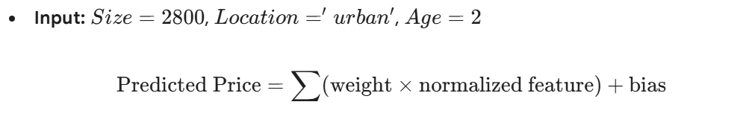 Predicted Price Result
For a house that is 2800 sqft, in an urban location, and 2 years old:

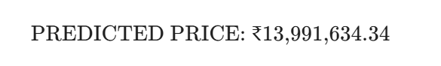
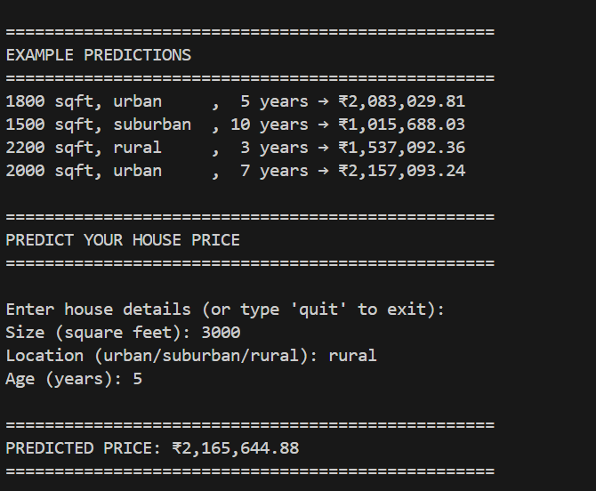

The model predicts a price of approximately ₹1.40 Crore for this hypothetical luxury house, which is a reasonable extrapolation given the characteristics of the most expensive homes in the training data.

